Evolution of Strepsirrhines/Prosimians and Haplorhines/Anthropoids

# Plesiadapiforms

* Looked like squirrels
* Small animals
* Relationship between these animals and trees
  + They eat the seeds of trees and pooped them out
  + Certain monkeys have to eat the seeds for them to germinate
* Narrow snout
* No postorbital bar; no enclosure behind the eye socket

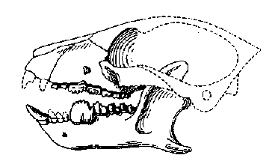

* + **Diastema:** a space separating teeth of different functions, especially that between the biting teeth
    - Bigger the diastema, the smaller the brain was
  + Small brain

# Chain of Evolution

* Adapoids → Lemurs, Loris Group
* Unfused mandibular symphysis, longer face, postorbital bar, no postorbital closure

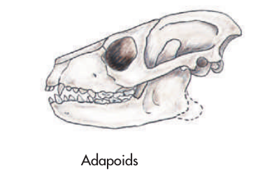

* Omomyoids → Higher primates, humans, tarsiers

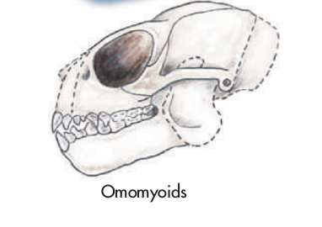

* **First true anthropoids**
  + 58-40 MYA
  + After great cooling 36 MYA
  + First monkeys Oligocene 35-50 MYA
    - First Apes

# EEA: Environment of Evolutionary Adaptedness

* During the Miocene
  + In the African tropics
* Total rainfall decline and became more seasonal
* Moist tropical forests shrank and drier environments expanded
* Earliest **hominins** were among the pioneers that survived this period of natural selection
  + Bipedal ape is a hominin
* **General definition**: it is the environment to which a species is adapted. In our case it is the general time frame in which humans developed from small primates into large hominins

## Hominin Origins

* From Hominid (Apes) to *Hominin*
  + Three different human species
    - Ardipithecus ramidus

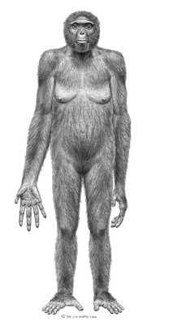

* + - Sahelanthropus Tchadensis

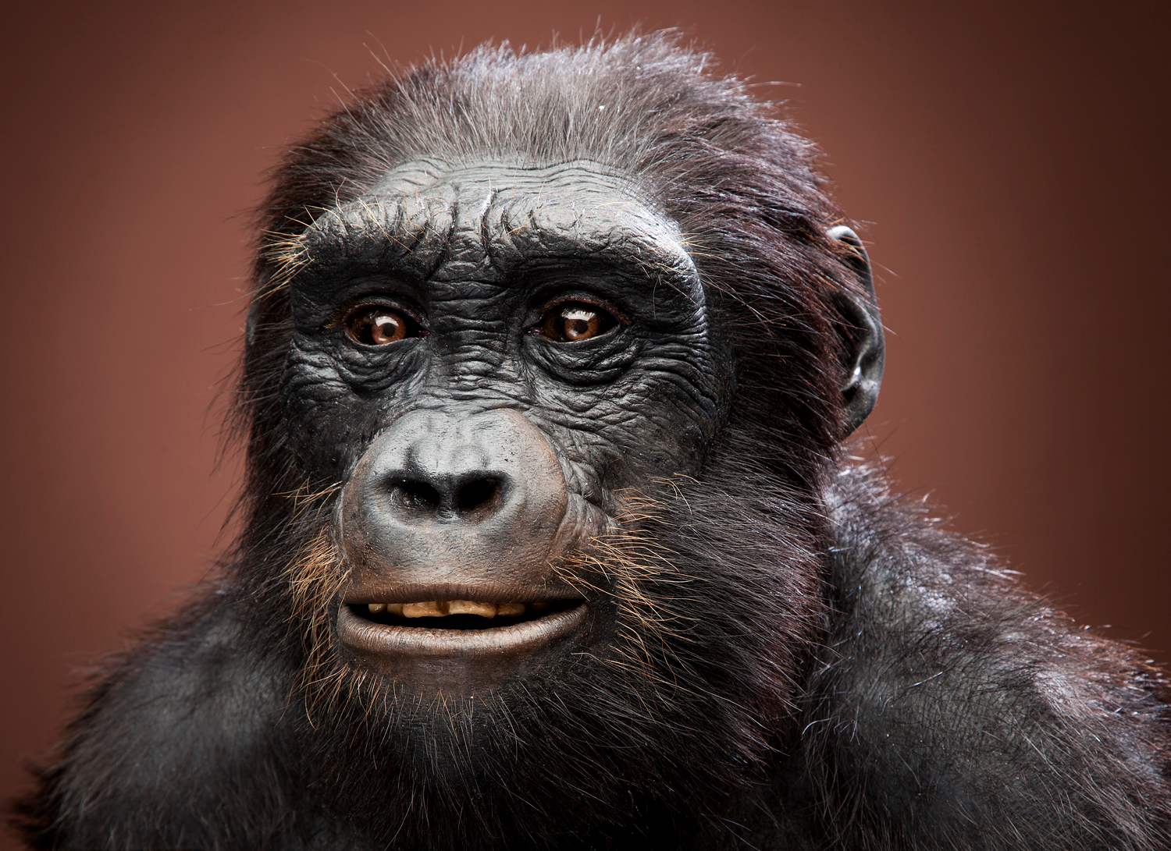

* + - Orrorin tugenensis

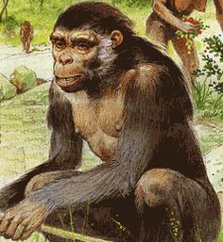

Two distinction from Miocene apes

* Bipedal
* Different chewing apparatus/skull

# Hominin radiation

Fossil apes characteristics

* Larger brain
* Extended growth period
* Knuckle walking
* Brachiator traits (rotating arm socket for swinging)
* Smaller canines

Hominins differ

* Even larger brain/body size
* Even more extended growth period
* Habitual bipedality
* Even more derived dentition and associated jaw/skull muscle

**Genetic Distance:** tells us about the timing of evolutionary branches

* How far apart are two species

# Evolution of Haplorhines/Anthropoids

Apidium → New World Monkeys

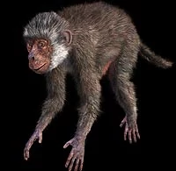

* Parapithecidae and last common ancestor to all living anthropoids
* Rafted from Africa to South America and became the ancestor to all extant members of five NWM (new world monkeys) subfamilies
* Dental formula of “2:1:3:3”
  + Incisors : Canine : Premolar : Molars

Aegyptopithecus: propliopithecidae and last common ancestor of all catarrhines

* *Dental formula of “2:1:2:3”*
* Victoriapithecus
  + Colobines

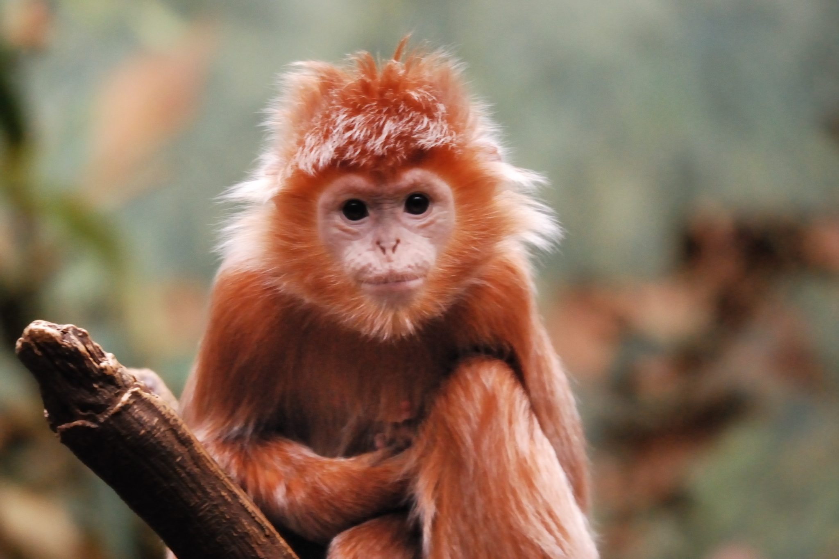

* + Cercopithecines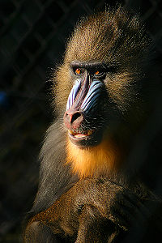
* Morotopithecus
  + Proconsul

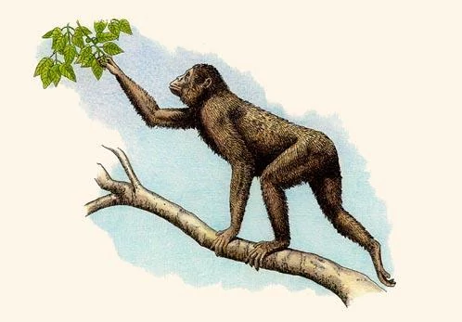

* + - Dryopithecus

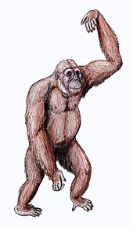

* + Gibbons
  + Orangutans
  + Kenyapithecus
  + Sivapithecus → Gigantopithecus
    - 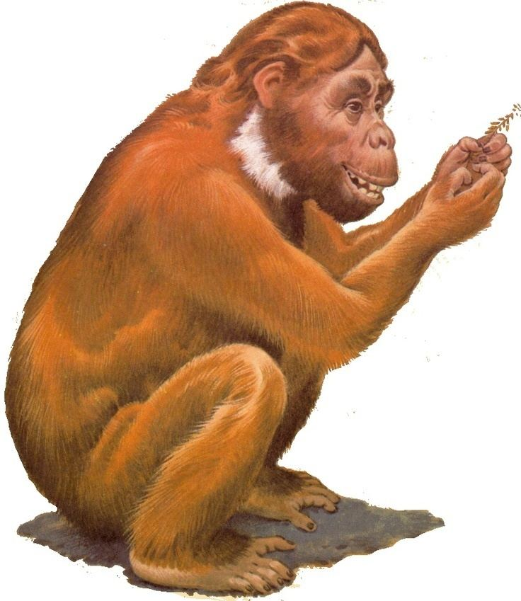
    - 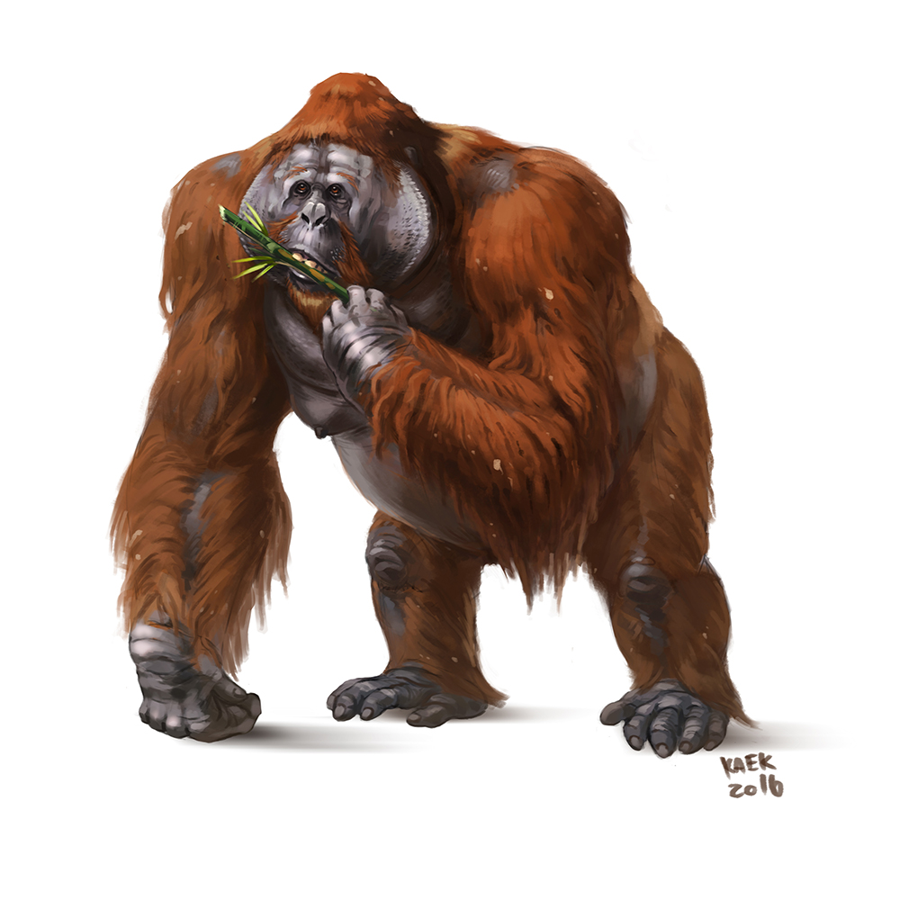
  + Gorillas
  + Chimpanzees
  + Humans